Section 1: Booth details (1 – 6)
Company details, subtitle & logo
Will be displayed in the virtual booth this way.

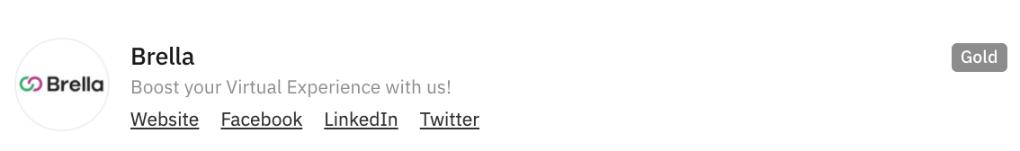

Nr | Category | Explanation | Your answers
1 | Project’s/organisation’s name | Name you’d like to have in the virtual booth
2 | Subtitle | Max. 75 characters. Can be a catchy phrase to get your virtual booth more views.
3 | Website URL | Website URL link
4 | Facebook URL | Facebook URL link (optional)
5 | Twitter ID | For example, @company (optional)
6 | LinkedIn URL | It can be a person’s or company’s

Additional: Sponsor ad copy
Copy for the ad (max. 280 characters)

Section 2: Company description (7 – 9)
Project/Solution description subtitle & logo
Will be displayed in the virtual booth this way.
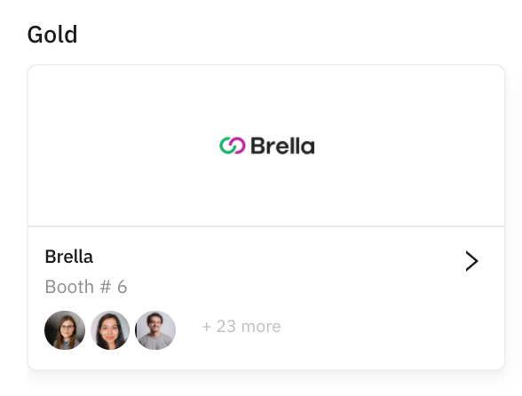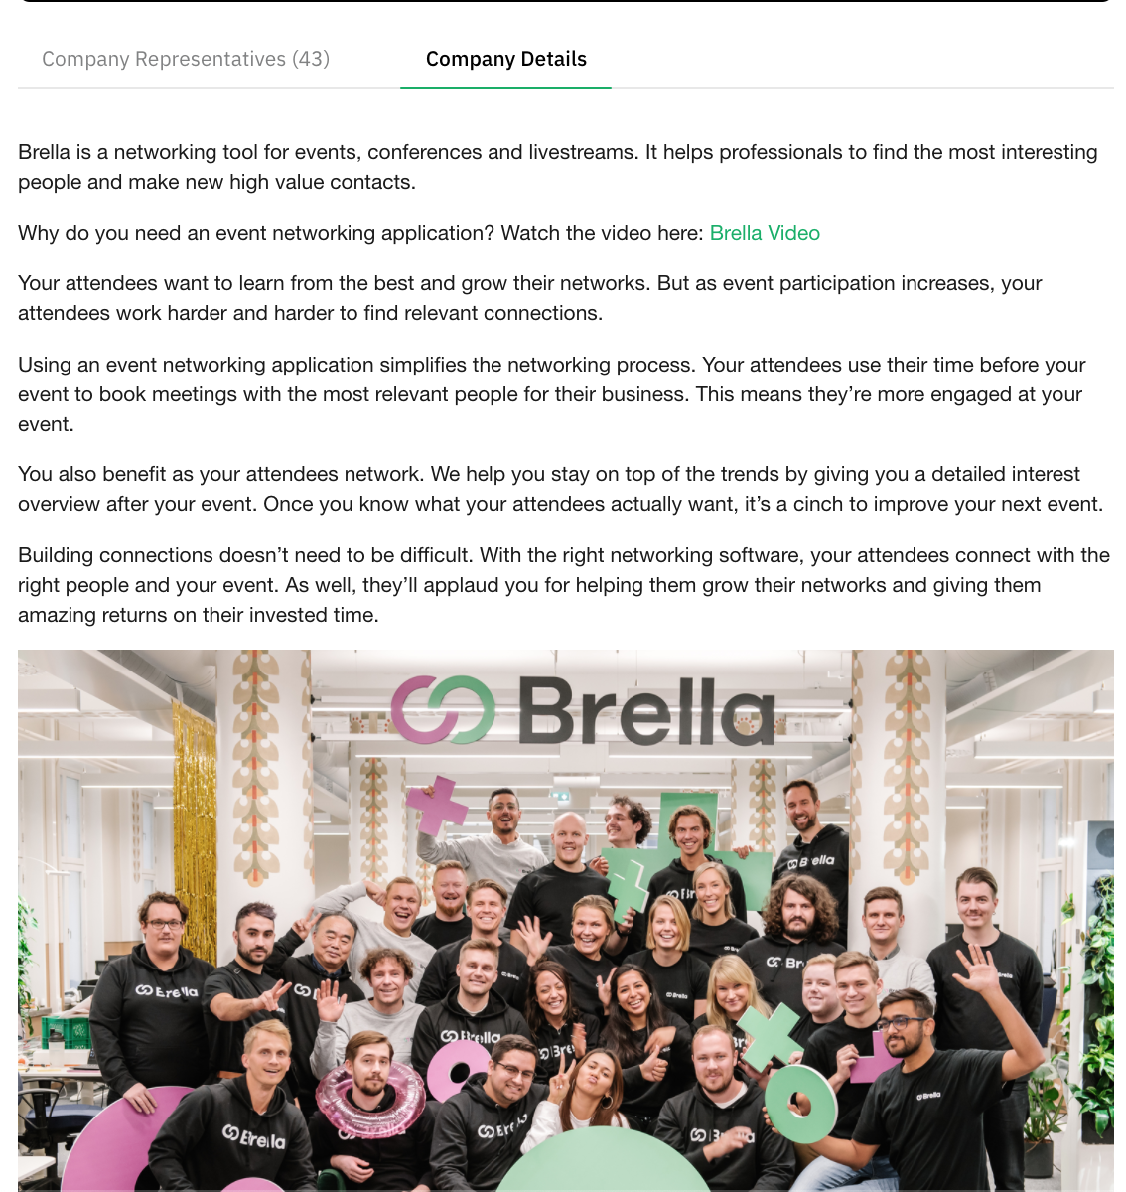
Nr | Category | Explanation | Your answers
7 | Brief description of the company/solution/organisation | Recommendation: 100 to 250 words.  For example, one or two paragraphs briefly describing what your company does. Too much text will saturate your booth.
8 | Other links or images you’d like to add to the booth | URL/links: Embed URL  or Format: jpeg. jpg. png. or gif (attached)  Recommendation: max. 2 embed links or images (see details in point 9). | 1. Name of the file:  Link/URL or attachment.
9 | Logo | Dimensions:(300x300 px)  Format: jpe. jpeg.png. or gif (attached)  Recommendation: Max.1. | Attach a photo to email

Section 3: Carousel section (10 – 12)
The carousel is placed in the middle of the booth.
the items in the carousel will be displayed in the virtual booth this way,
and to view other items you can click on the right arrow.
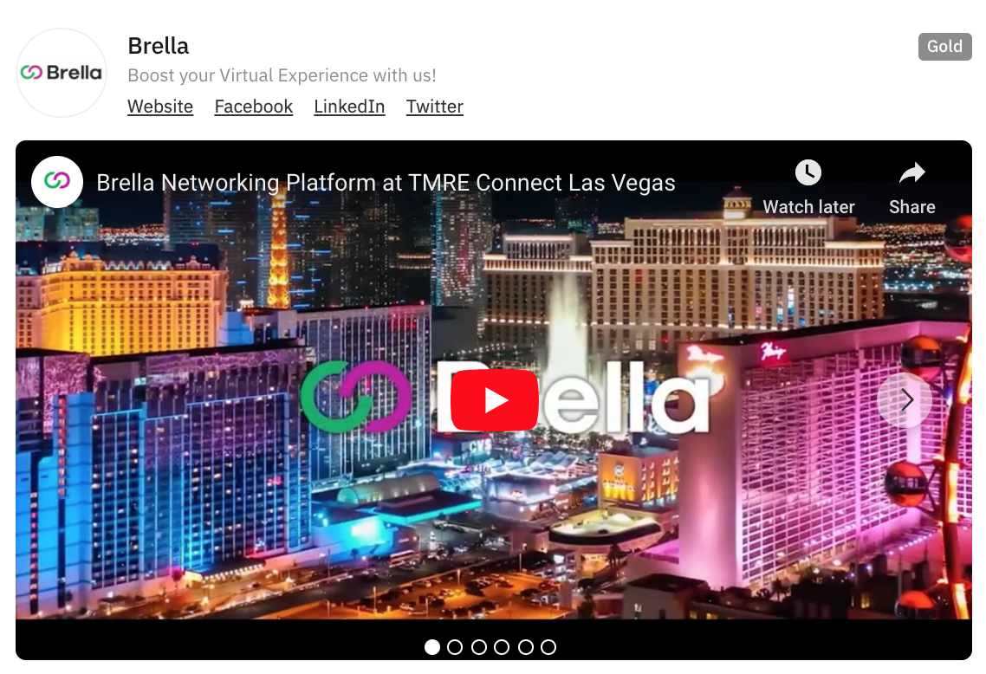
Nr | Category | Explanation | Your answer: add links
10 | Promo video URL | Format needed: Embed URL/link  Recommendation: max. 2 videos (Dimensions 736x400 pixels)  To guarantee the speed of the platform we do not accept mp4 or similar documents, only URL links. There are numerous YouTube tutorials explaining how to upload videos to the platform and retrieve the embed URL. | Name of the file:  Link/URL:
11 | Document .pdf, slides, ppt, website, blog post, etc. | Format needed: Embed URL (dimensions 736x400 pixels).  Recommendation: max. 2 files. Too long/big documents will saturate your booth. Learn how to get the embedded link from a doc on GDrive here. For websites, web pages, posts (LinkedIn only), share the regular URL. For surveys, poll, Q&A, etc. We need the embed URL as well. This can be retrieved from the provider’s dashboard. | Name of the file:  Link/URL:
12 | Images | Format needed: jpg, .png, or .gif attached by email or compressed in a link.  Recommendation: max. 2 images.  Dimensions: to optimize the visibility of the images in your virtual stand, we suggest photos in panoramic orientation, 16:9 scale, and dimensions 736x400 pixels (approx). Oversized photos will saturate your booth (+1MG). | Name of the file:  Link/URL or attachment.

Section 4: Sidebar section (13)
The sidebar is placed on the right side of the booth.
The items on the side will be displayed in the virtual booth this way,
and to view other items you can click on the title.

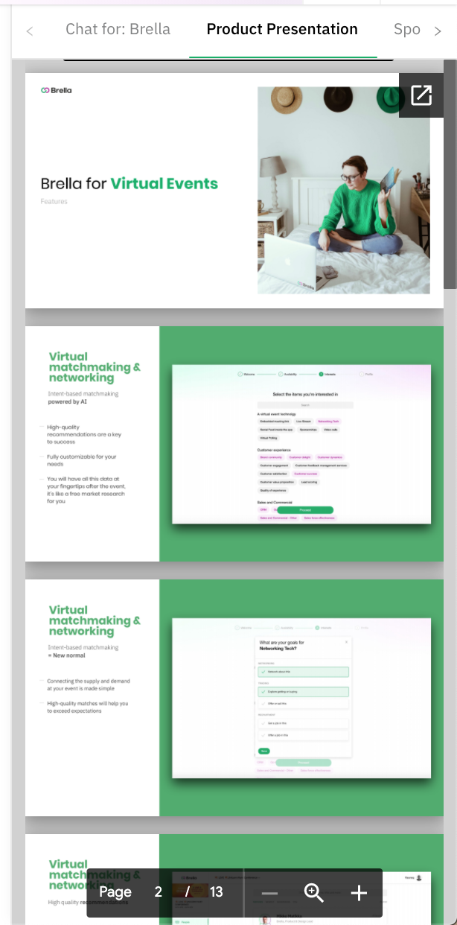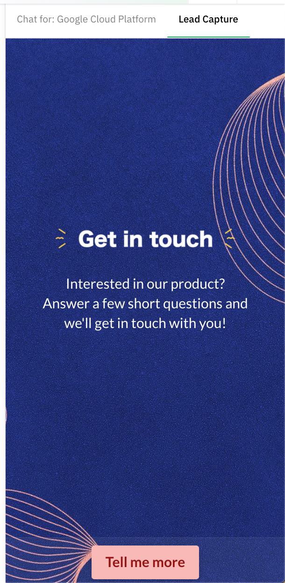
Nr | Category | Explanation | Your answer: add links
13 | Document.pdf or web page (it should be embeddable) | Format needed: Embed URL/link. Website usual link.  Recommendation: max 2 files. Send us the .pdf file(s) as an embed URL by email. Learn how to get the embedded link from a doc on GDrive here. For websites, web pages, posts (LinkedIn only), share the regular URL. For surveys, poll, Q&A, etc. We need the embed URL as well. This can be retrieved from the provider’s dashboard. | 1.Name of the file:  Link/URL:  2.Name of the file:  Link/URL:

